**Configure MySQL Master with Relay-Slave**

**Scenario:**

**Master --> Relay --> Slave**

**MySQL04 - 192.168.0.145 (Master)**

**MySQL05 - 192.168.0.146 (Relay-Slave)**

**MySQL06 - 192.168.0.147 (Slave)**

**MySQL04 - 192.168.0.145 (Master)**

* Edit /etc/my.cnf and add below in the configuration

server-id = 1

binlog-do-db=replication

relay-log = /var/lib/mysql/mysql-relay-bin

relay-log-index = /var/lib/mysql/mysql-relay-bin.index

log-error = /var/lib/mysql/mysql.err

master-info-file = /var/lib/mysql/mysql-master.info

relay-log-info-file = /var/lib/mysql/mysql-relay-log.info

log-bin = /var/lib/mysql/mysql-bin

binlog-ignore-db=mysql

* Login to MySQL server using root credential

Mysql> grant replication slave on *.* to 'user'@'%' identified by 'password';

Mysql> FLUSH TABLES WITH READ LOCK;

Mysql> SHOW MASTER STATUS;

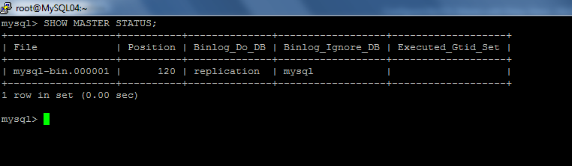

* mysqldump -u root -p --all-databases --master-data > /root/dbdump.db
* Copy the dbdump.db file to Relay-Slave server
* Mysql> UNLOCK TABLES;

**MySQL05 - 192.168.0.146 (Relay-Slave)**

server-id = 2

binlog_format = row

replicate-do-db=replication

binlog-do-db=replication

relay-log = /var/lib/mysql/mysql-relay-bin

relay-log-index = /var/lib/mysql/mysql-relay-bin.index

log-error = /var/lib/mysql/mysql.err

master-info-file = /var/lib/mysql/mysql-master.info

relay-log-info-file = /var/lib/mysql/mysql-relay-log.info

log-bin = /var/lib/mysql/mysql-bin

log-slave-updates

expire_logs_days = 10

max_binlog_size = 500M

innodb_flush_log_at_trx_commit = 1

sync_binlog = 1

replicate-wild-ignore-table = mysql.%

# service mysqld restart

Mysql -u root -p < dbdump.db

Mysql> CHANGE MASTER TO MASTER_HOST='192.168.0.145', MASTER_USER='user', MASTER_PASSWORD='password', MASTER_LOG_FILE='mysql-bin.000001', MASTER_LOG_POS=120;

Mysql> start slave;

Mysql> grant replication slave on *.* to 'user'@'%' identified by 'password';

Mysql> show master status;

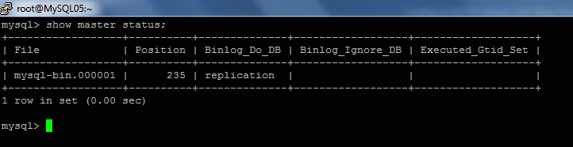

**MySQL06 - 192.168.0.147 (Slave)**

* My.cnf configuration

server-id = 3

binlog_format = row

replicate-do-db=replication

relay-log = /var/lib/mysql/mysql-relay-bin

relay-log-index = /var/lib/mysql/mysql-relay-bin.index

log-error = /var/lib/mysql/mysql.err

master-info-file = /var/lib/mysql/mysql-master.info

relay-log-info-file = /var/lib/mysql/mysql-relay-log.info

log-bin = /var/lib/mysql/mysql-bin

* Service mysqld restart
* Mysql> CHANGE MASTER TO MASTER_HOST='192.168.0.146', MASTER_USER='user', MASTER_PASSWORD='password', MASTER_LOG_FILE='mysql-bin.000001', MASTER_LOG_POS=235;
* start slave;